

**A**

**PROJECT REPORT**

**ON**

**“ ONLINE FOOD ORDERING ”**

**Submitted to,**

**Computer Science And Engineering**

**Faculty of Engineering and Technology (Co-Education)**

**In partial fulfillment of the semester project.**

**Submitted By**

**KARTIK.G SG20CSE060**

**BHUMIKA.D SG20CSE301**

**KUSHAL.S SG20CSE066**

**LAXMIKANT.K SG20CSE067**

**Under the guidance of**

**Prof. SAVITA PATIL**



**CERTIFICATE**

This is to certify that the project work entitled “**ONLINE FOOD ORDERING** ” is bonafide work carried out by **LAXMIKANT,BHUMIKA,KARTIK,KUSHAL** in partial fulfillment of **B.Tech 6Th Semester in Computer science and Engineering** of the Faculty of Engineering and Technology (Co-Education), **SHARNBASVA UNIVERSITY**, **Kalaburagi** during the year 2022-2023. It is certified that, she/he has completed the project satisfactorily.

**MARKS DETAILS**

|  |  |  |  |  |
| --- | --- | --- | --- | --- |
| **SL**  **NO.** | **Name of the student** | **USN** | **MAXIMUM**  **MARKS** | **MARKS**  **OBTAINED** |
| 01 | KARTIK.G | SG20CSE060 |  |  |
| 02 | LAXMIKANT.K | SG20CSE067 |  |  |
| 03 | BHUMIKA.D | SG20CSE301 |  |  |
| 04 | KUSHAL.S | SG20CSE066 |  |  |

**Guide Chairman Dean**

**Name of the Examiner Signature with date**

**01.**

**02.**

**CONTENT**

* ACKNOWLEDGEMENT
* ABSRACT
* CHAPTER 1

INTRODUCTION

* CHAPTER 2

LANGUAGE USED

* CHAPTER 3

SOURCE CODE

* CHAPTER 4

ADVANTAGES AND DISADVANTAGES

* CHAPTER 5

OUTPUT

* CHAPTER 6

FUTURE SCOPE

* CHAPTER 7

CONCLUSION

**ACKNOWLEDGEMENT**

We express our deep sense of gratitude to our esteemed **“SHARNBASVA UNIVERSITY” KALABURAGI** which has provided us an opportunity to fulfil the most cherished desire to reach our goal.

We also extend our sincere thanks to **Dr. ANILKUMAR BIDVE**, Registrar, Sharnbasva University, for his constant encouragement.

We would like to express our sense of gratitude to our beloved **Dr.SHIVKUMAR JAWALGI** , Dean for providing the right academic climate at this university that has made this entire task appreciable.

We are thankful to **Prof. S.A MADIVAL** Chairman, department of Computer Science & Engineering, for giving permission to carry out this project in the university.

We wish to place our grateful thanks to our project guide **Prof .SAVITA PATIL** without their help and guidance, it would not have been possible to complete this project work.

Finally we express our heartily thanks to all of our staff members of our department, who helped us a lot in the completion of project directly period.

BHUMIKA .D : SG20CSE301

KUSHAL.S : SG20CSE066

LAXMIKANT.K : SG20CSE067

KARTIK.G : SG20CSE060

**ABSTRACT**

The purpose of Online Food Ordering System is to automate the existing manualsystem by the help of computerized equipment’s and full-fledged computer software,fulfilling their requirements, so that their valuable data/information can be stored for alonger period with easy accessing and manipulation of the same. The required softwareand hardware are easily available and easy to work with.Online Food Ordering System, as described above, can lead to error free,secure, reliable and fast management system.

The objective of this project is to create a user-friendly interface for customers to order food items online. The Java Swings framework is employed to construct the graphical user interface, allowing for an intuitive and interactive experience. Java Applet technology facilitates the integration of the application into web browsers, enhancing accessibility. The system relies on database connectivity to store and manage food item information, order details, and customer data. Through this combination of technologies, users can browse the menu, place orders, and view their cart and at last generate bill or invoice seamlessly. The utilization of Java Swings, Java Applet, and database connectivity demonstrates the potential for creating efficient and engaging online food ordering platforms.

**CHAPTER1**

**INTRODUCTION**

The Simple Ordering System in Java using concept called swing and applet is a desktop application coded in a Java programming language. The project uses a simple function to make the Ordering System work as it is intended. This project can make an order for the customer select food item. The user can manage the food listing by adding new food item, update, and remove. This Simple Ordering System is a simple project that can help students taking IT related courses for their project proposal. The project can benefit you if you have a food business that needed an efficient transaction. This Simple Ordering System in Java that provide a new coding techniques in Java programming. Through this combination of technologies, users can browse the menu, place orders, and view their cart and at last generate bill or invoice seamlessly.

**CHAPTER2**

**LANGUAGE USED**

Here we are using JAVA language using swing and applet concept as Front End and also to store the data we are using MYSQL that is structured query language as Back End development.

Front End development:

1. JAVA Swing

2. Applets

Back End development:

3.MYSQL

1. JAVA Swing: Java Swing tutorial is a part of Java Foundation Classes (JFC) that is used to create window-based applications. It is built on the top of AWT (Abstract Windowing Toolkit) API and entirely written in java.Unlike AWT, Java Swing provides platform-independent and lightweight components.The javax.swing package provides classes for java swing API such as JButton, JTextField, JTextArea, JRadioButton, JCheckbox, JMenu,JColorChooser etc.The Java Foundation Classes (JFC) are a set of GUI components which simplify the development of desktop applications.

2. Applet: An applet is a Java program that runs in a Web browser. An applet can be a fully functional Java application because it has the entire Java API at its disposal. Every applet is an extension of the java.applet.Applet class. The base Applet class provides methods that a derived Applet class may call to obtain information and services from the browser context.

Life cycle of an applet:

1.init

2.start

3.stop

4.destroy

5.paint

3. MYSQL:SQL stands for Structured Query Language. It is used for storing and managing data in relational database management system (RDMS). It is a standard language for Relational Database System. It enables a user to create, read, update and delete relational databases and tables.

SQL allows users to query the database in a number of ways, using English-like statements.Using the SQL statements, you can perform most of the actions in a database.SQL depends on tuple relational calculus and relational algebra.

**CHAPTER 3**

**SOURCE CODE**

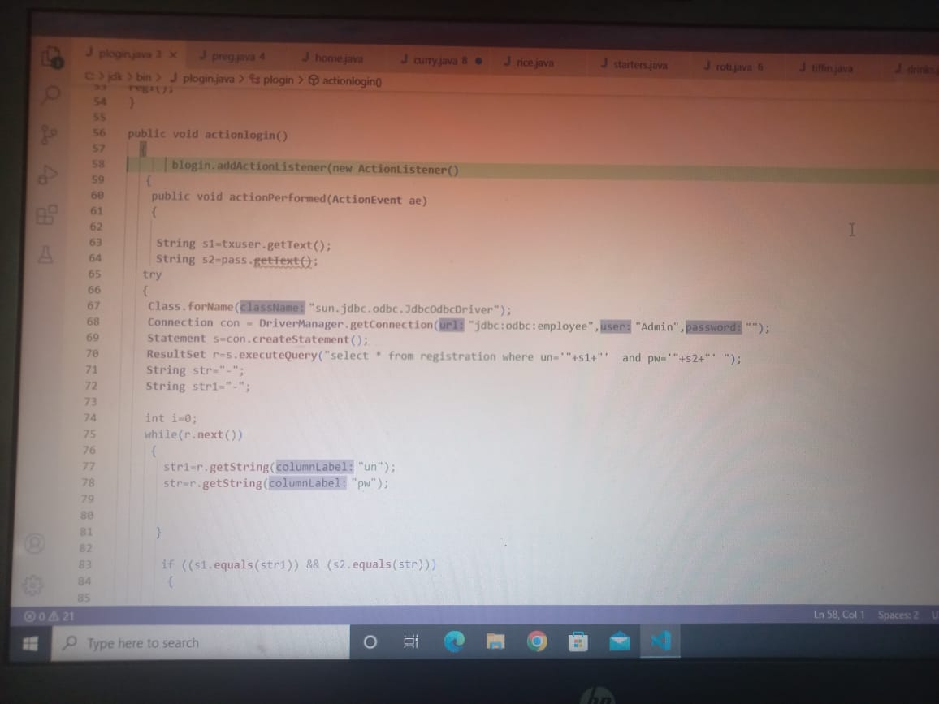

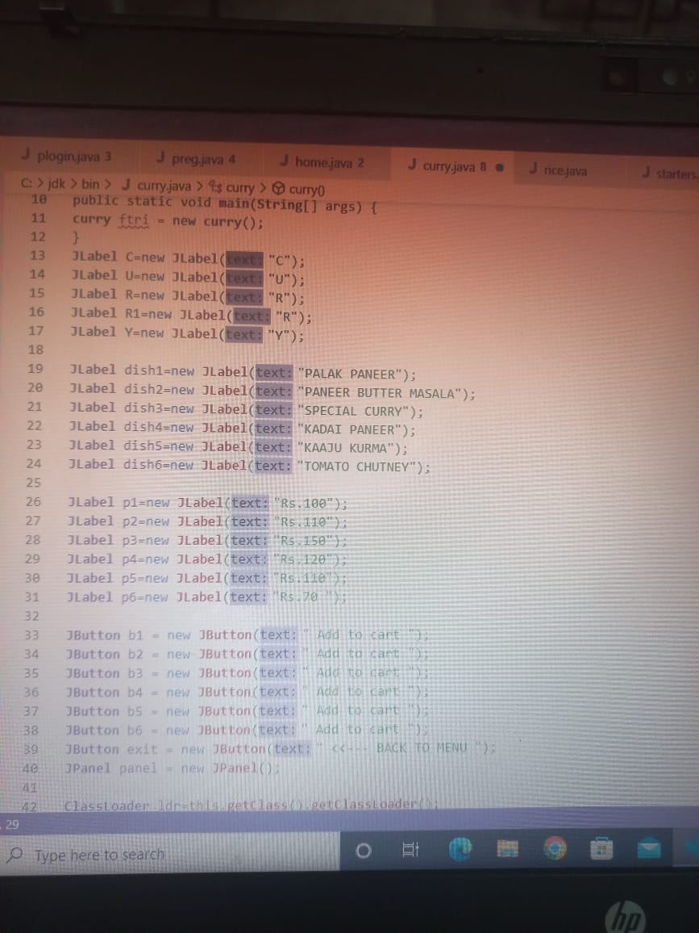

**CHAPTER 4 :**

**ADVANTAGES AND DISADVANTAGES**

Advantages:

1. The food ordering process easier for customers as well as for restaurant owners.

2. Easy order management.

3. It is very eassy to customize the food order.etc

Disadvantages:

1. It is way overpriced .

2. Losing human touch .

**CHAPTER 5 :**

**OUTPUT**

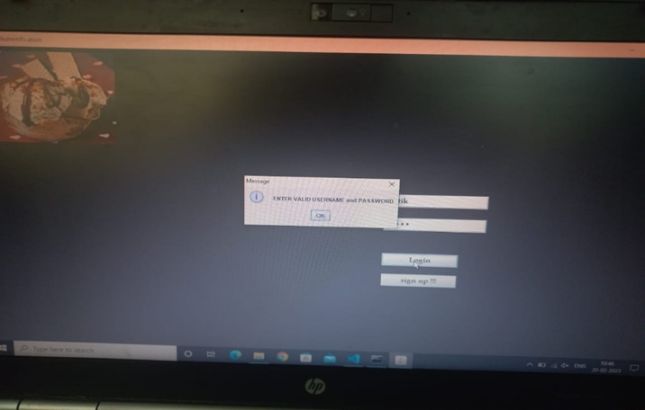

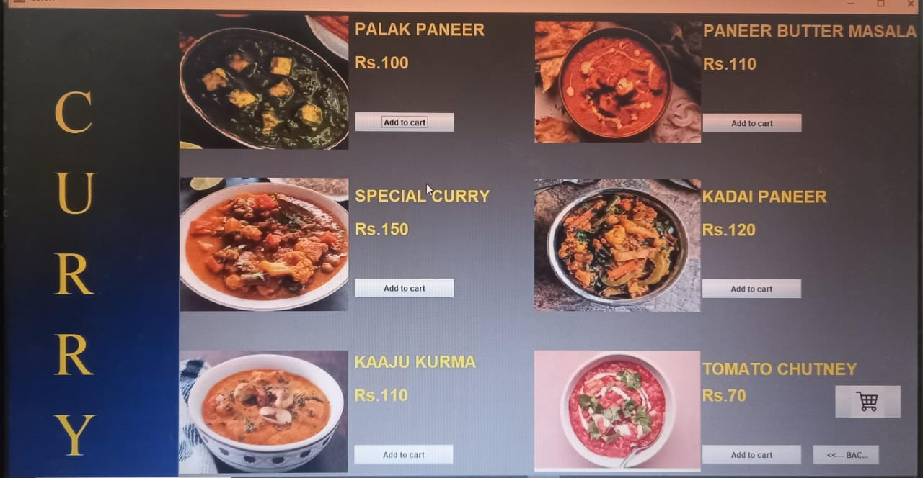

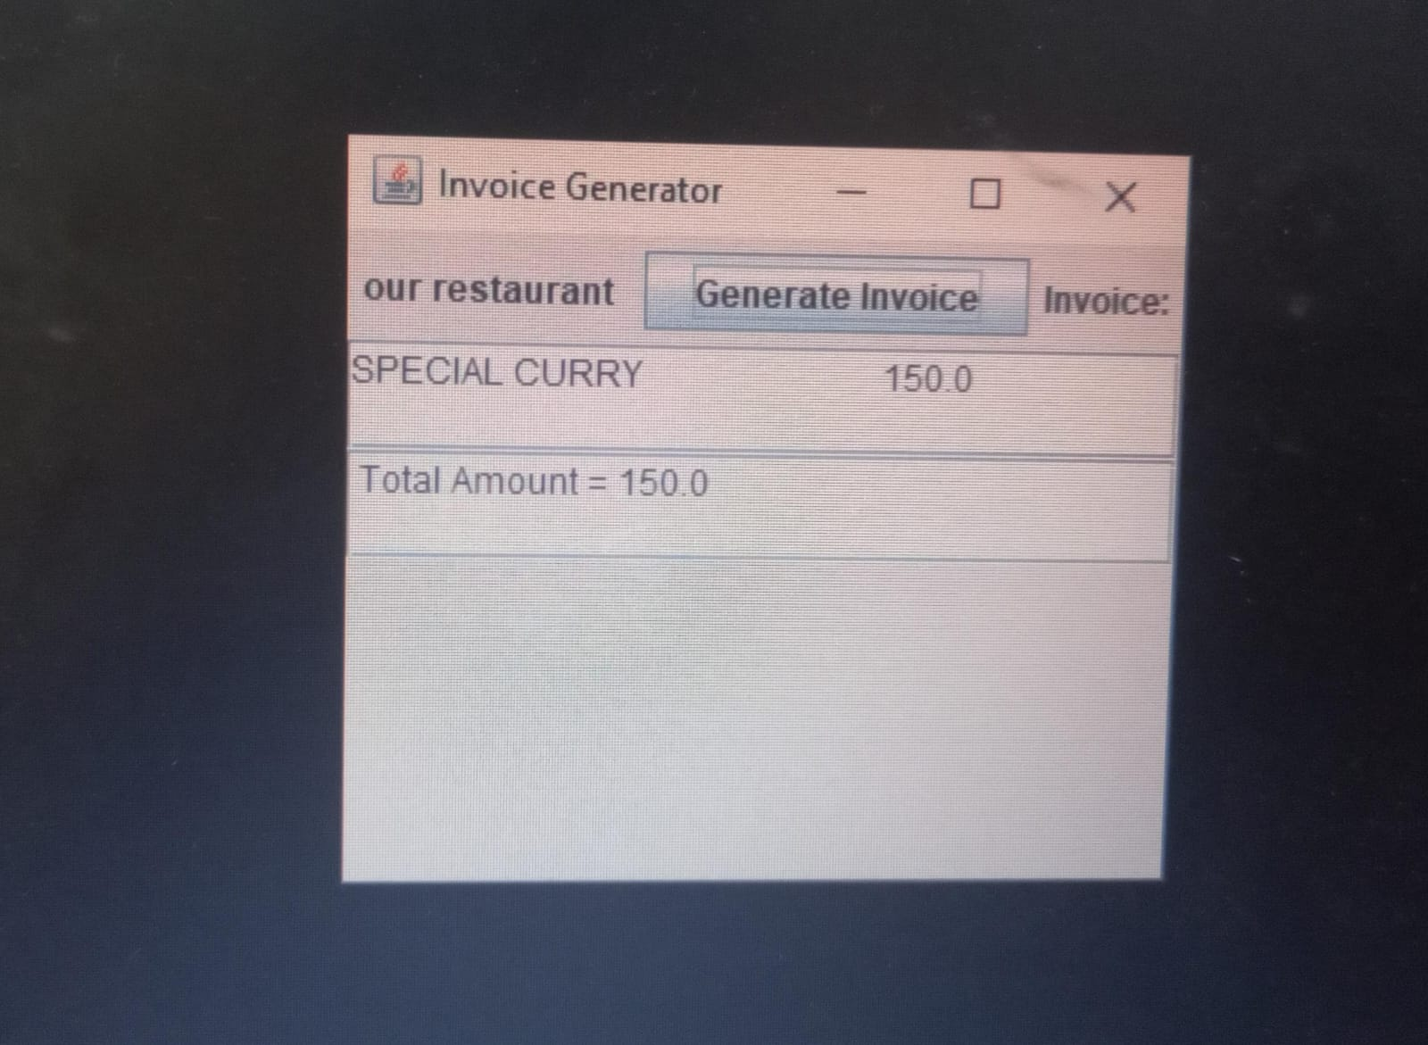

**CHAPTER 6 :**

**FUTURE SCOPE**

The future scope of this project is that we can convert this into application using Python, Java, C++ etc. And hosting this application in browser or website is possible using JSP and Servlets , WASM .

Here we are showing the selected food items that are stored into cart and calculating the total amount or price of the selected items with taxes and discounts included. But the real time amount transaction through various technologies like net-banking, card, online payment through UPIs is yet to be developed in future .

Hence future enhancements could include integration with real-time tracking, customer reviews, and seamless communication between users and restaurant .

**CHAPTER 7 :**

**CONCLUSION**

The online food ordering system application designed using Java Swing offers a user-friendly interface for customers to conveniently browse, select, and order their desired food items. The utilization of Java Swing provides a responsive and interactive platform, enhancing the overall user experience. With features like menu visualization, order customization, and secure payment options, the application streamlines the food ordering process. However, to further improve the system, future enhancements could include integration with real-time tracking, customer reviews, and seamless communication between users and restaurants. Overall, the application demonstrates the effective use of Java Swing to create a practical and efficient online food ordering solution.

***THANK YOU***